Hello everybody,  
In June 2019, chillibasket made the model of the WALL-E Robot Replica available at www.thingiverse.com/thing:3703555. A great model with great functions. I started to build this model and I think the suspension could be improved.  
The chains are 35 chain links long on each side, which means that the chains sag quite a bit. That may be intentional, but I saw a need for action here in the form of equipping WALL-E with chain tensioners. Almost all parts have been changed, except for the small and the front rollers and the associated axles. I also shortened the chain by one link each.

The aim was to have the upper chain guide roller perform this function using a compression spring (size 30x8x1mm). The "Frame_right" was redesigned and divided into two parts.

Firstly, the main part and the functional part

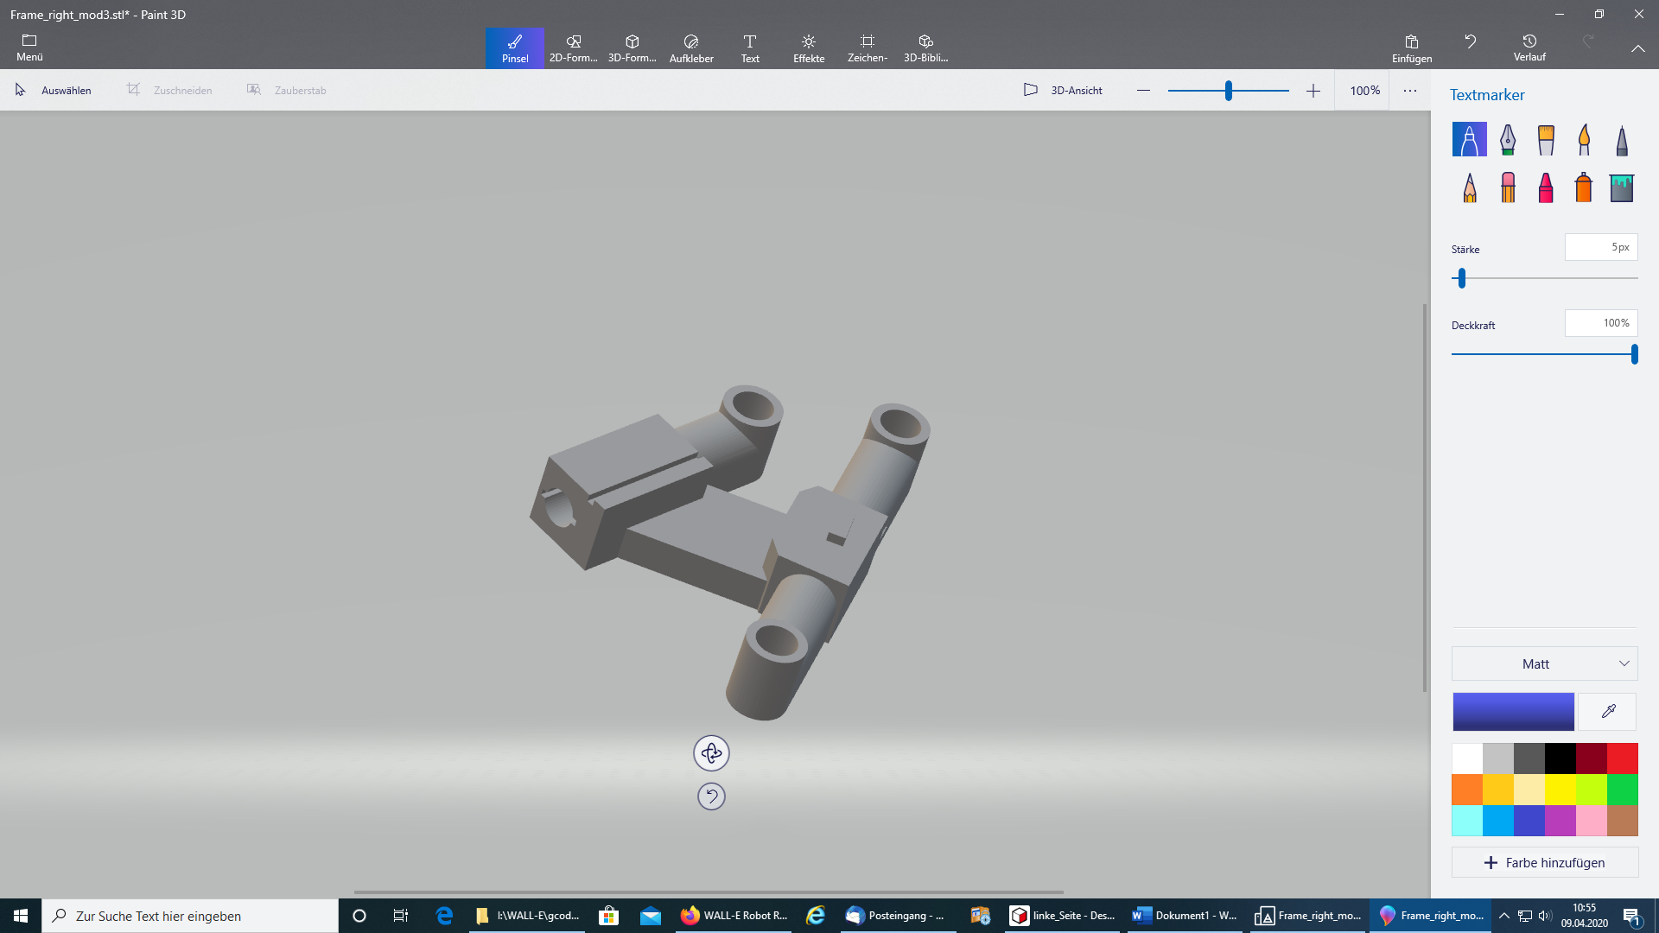

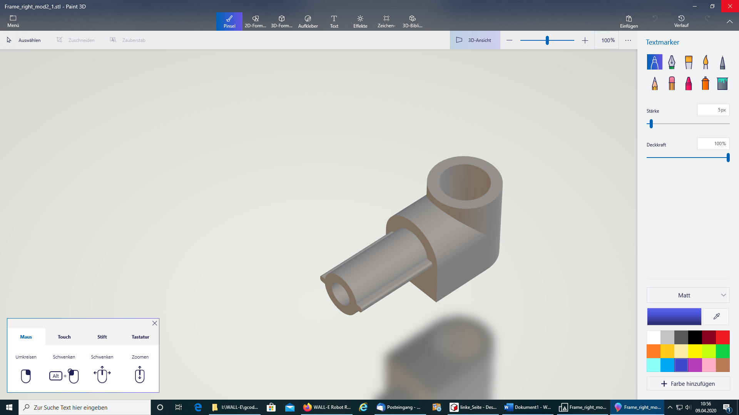

I used an Allen screw M3x25 to stabilize the central axis of the functional part.  
The hole in the main part receives the compression spring and the functional part is later inserted into the guide under pressure when assembled with the chain. (a bit complicated, but it works)

Ein Bild, das drinnen, weiß, Foto, sitzend enthält.

Since I was already able to access the chassis, I immediately designed the motor drive gear with a fit as specified by the axis of the motor.

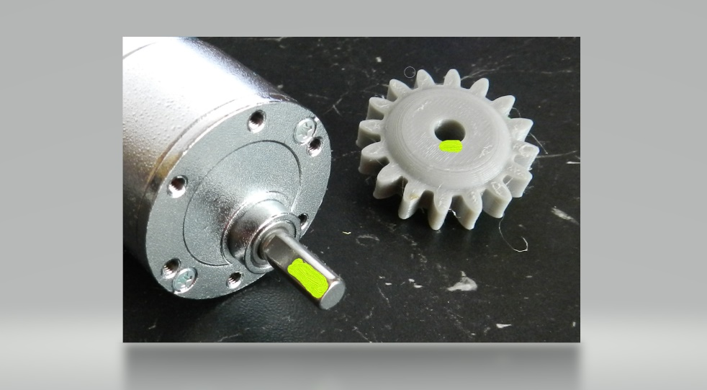

In order to transfer the driving force from the motor to the chain via the gears, I considered whether it would not make sense to use a hexagon axis instead of a 10mm hole in the chain wheel and the associated drive gear. For this I have provided the relevant parts with a hexagon fit and the drive axle also with a hexagon.

Ein Bild, das Wasser, weiß, sitzend, schwarz enthält.
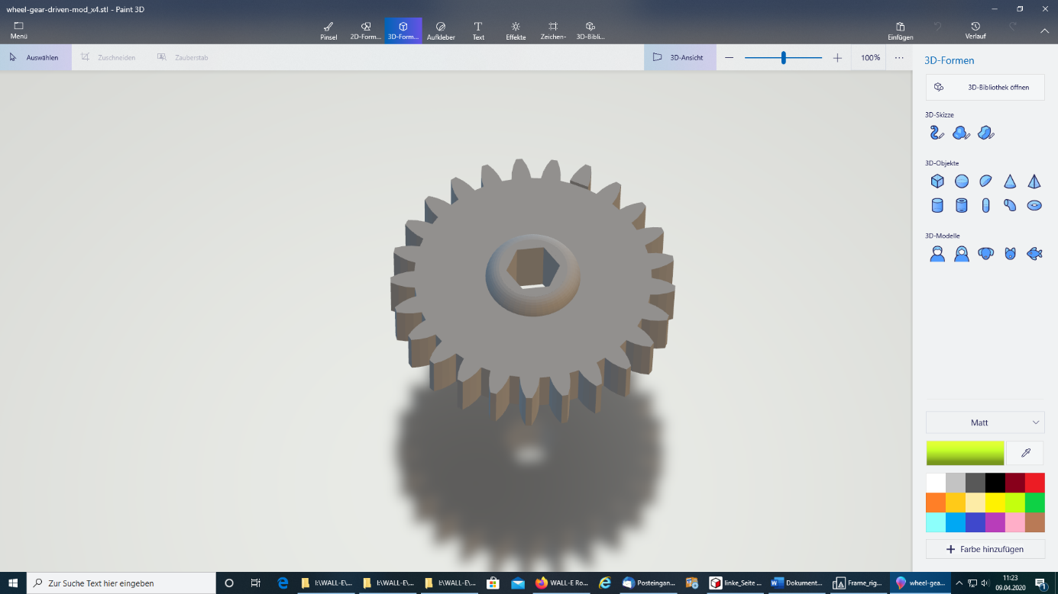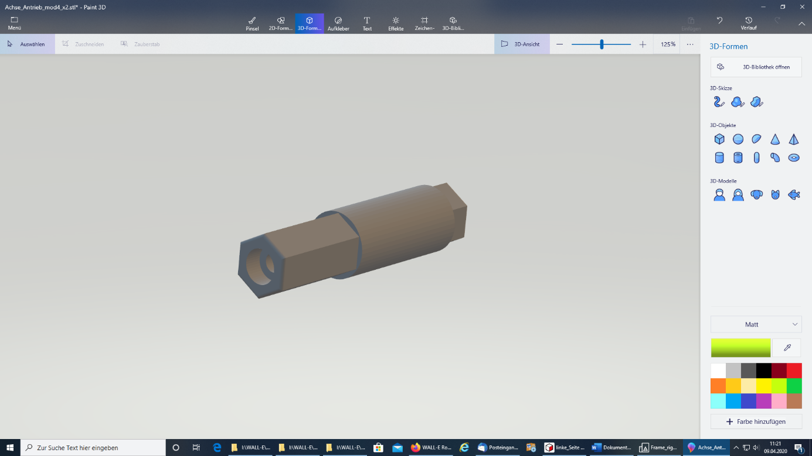

This also includes that  
Sprocket.

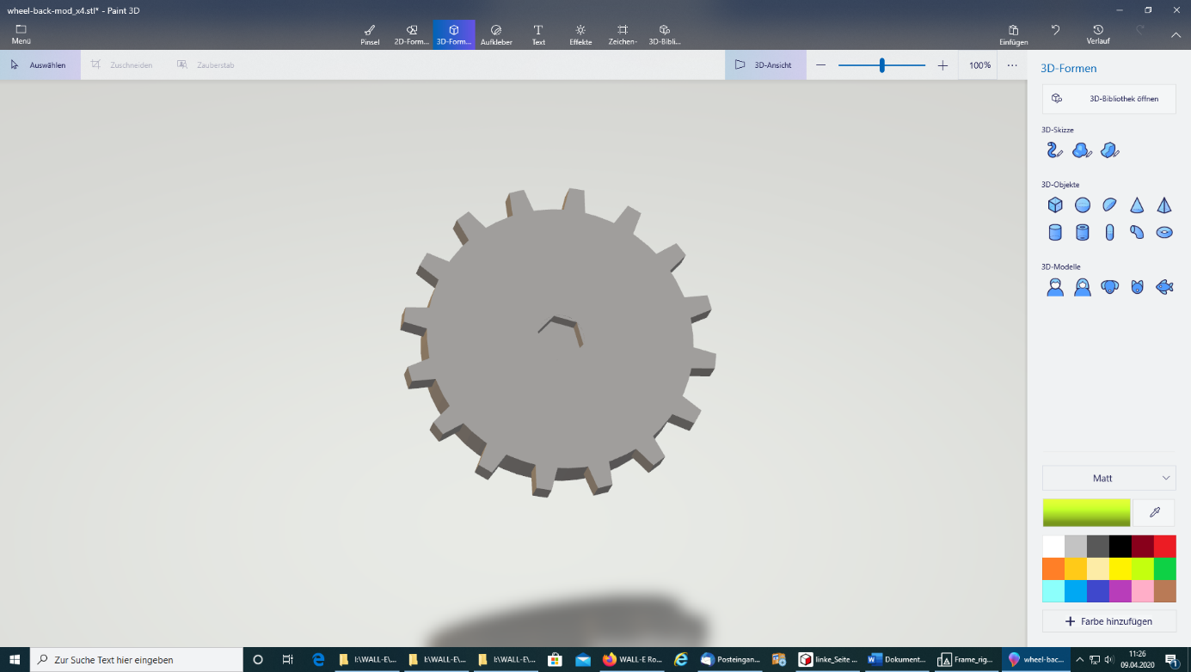

Laying on the chain is a little more difficult than it is without the chain tensioner, but it is doable.  
The disadvantage of this whole change is that almost all parts of the chassis have to be reprinted and it takes a lot of time.